 | Brand Technology Services  4150 East 5th Avenue  Columbus, OH 43219

bTs Document
Incident Response Procedure

Document Control

Change Record

Date | Author | Version | Change Reference
08-14-2007 | Aaron Woody | 1.0 | Initial Draft
08-14-2007 | Rob Burns | 1.1 | Format changes, added comments
08-20-2007 | Aaron Woody | 1.2 | Accepted changes to document

Reviewers

Name | Review Date
Rob Burns | 08-14-2007
Jamil Siddique | 08-15-2007

Document Location

Copy No. | Name | Location
 | <Name of the file> | <Location of the file>

Preface

Audience
This document is intended for incident handlers who perform incident investigations to resolve incident cases.

Document Conventions

Convention | Meaning | Example
Times New Roman 20 Bold | Section Heading | Overview
Times New Roman 14 Bold | Topic Heading under a section | Document Conventions
Times New Roman 12 | General text | Create an Oracle Database
Times New Roman 12 Italics | System commands | mkdir unix

TABLE OF CONTENTS

Document Control 2
Preface 3
Overview 5
Incident Summary 6
Case Initialization 6
Contact Information 7
Incident Summary 8
Incident Detail 9
Incident Detail - Summary 9
Incident Detail – Source Host Information 10
Incident Detail – Affected System(s) Information 11
Incident Detail - Other Organizations, Evidence 12
Incident Detail – Resolution, Sign-off 13
Appendix A – Incident Response Flow 15
Appendix B – Case Classification, Prioritization, and Notification 16
Case Classification 16
Case Prioritization 16
Incident Escalation 17
Incident Notification 18
Appendix C - Incident Handler Resources 19
Tools, Commands, and Web Sites 19
Additional Resources 19

Overview

This document provides procedural steps for incident handlers to follow while performing investigative techniques to resolve an open incident case.

Case Investigation Guideline

- Identify threat
- Identify affected hosts
- Determine case priority
- Determine incident notification requirements
- Perform investigative tasks
- Resolve case

Incident Summary

Document the following information in the Summary section of the Incident Response Form. This allows for a quick synopsis of what the case is and where it is in the process.

Case Initialization

The current date and time will automatically populate in the form. The CIRT member for case initialization is responsible for completing the following fields in the form.

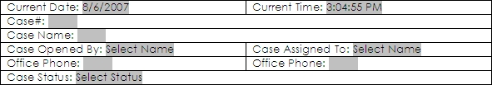

- Case# - enter the new case # following the case numbering standard,
example yyyyddmm-CIRT-ssss (s = sequence, case 1 would be 20071308-CIRT-0001)
- Case Name: - this should be a short descriptive title for the case.
- Case Opened By: - if you are initializing a new case, select your name form the drop down list.
- Case Assigned to: - select the security engineer or CIRT member the case is assigned to. This individual is responsible for seeing the case through until closed.
- Office Phone: - the office phone should be provided for both the initiator of the case and the assigned CIRT member. This should include area code.
- Case Status: - Select the current overall case status from the drop down list. This is an overall indicator.

Contact Information

The contact information section is used to document who or where we learned of the incident that has initialized a case. If contacted by a person complete the “Contact Information” section of form, if initialized per system notification, complete “System Notification” section of form.

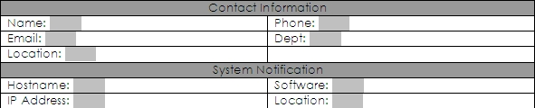

- If person;
  - Name: - provide name of incident contact (Who notified CIRT?).
  - Phone: - enter phone number of person who notified CIRT.
  - Dept. – enter the dept. for person who notified CIRT.
  - Location – enter corporate location of person who notified CIRT.
- If system;
- Hostname: - enter the hostname of the system that notified CIRT.
- Software: - enter software package running on the system that identified incident.
- IP Address: - enter IP address of system that notified CIRT.
- Location: - enter corporate location of the system that notified the CIRT.

Incident Summary

This section serves as a quick view into what investigative work has been completed and what is to be completed. As communication expands it is important to record contacts in an easily and quickly viewed section of the report.

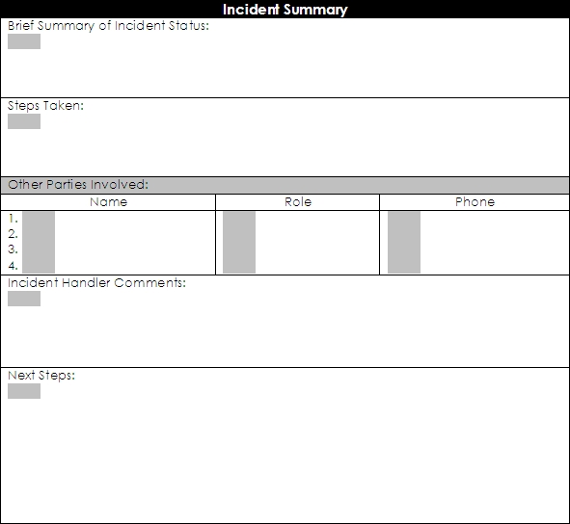

- Brief Summary of Incident Status: - this section should include a short paragraph of where the case is in the process.
- Steps Taken: - this section should include all steps taken to date on the case. This can be in a simple comma delimited format or bullets.
- Other Parties Involved: - simply any other individuals, groups, vendors, etc. that are involved due to their expertise, ownership, etc.
- Incident Handler Comments: - this section is for handler comments providing documentation of incident handler’s line of reasoning based on evidence, etc.
- Next Steps: - this section should outline what the next steps are to move forward or complete the investigation.

Incident Detail

This section includes all detailed information about the case. There are many specialized tasks including interviews, log review, and tools required to complete these sections. There are resources provided in the appendixes to serve as references.

Incident Detail - Summary

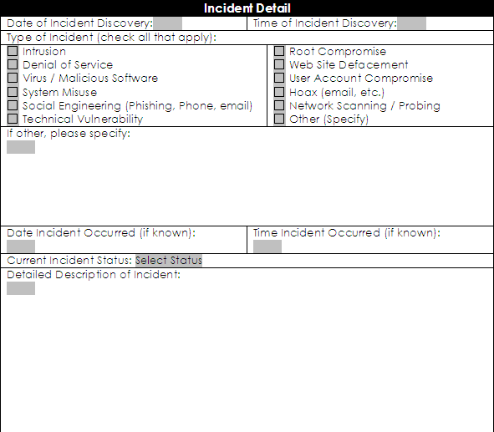

- Date of Incident Discovery: - enter date the incident discovered. This may or may not be date of incident notification.
- Time of Incident Discovery: - enter time the incident was discovered. This may or may not be time of incident notification.
- Type of Incident: - indicate the type of incident by checking appropriate boxes. If the incident does not fall within supplied types, include a description of the incident in the “other” box.
- Date Incident Occurred: - enter date incident actually occurred.
- Time Incident Occurred: - enter time incident actually occurred.
- Current Incident Status: - select status from drop down list. Status can include in progress, stopped, etc.
- Detailed Description of Incident: - the incident handler is to provide a detailed description of the incident, including a summarization of data and details discovered during investigation.

Incident Detail – Source Host Information

To complete this section the incident handler may have to run specialized tools, perform interviews and additional tasks such as log review, etc. There are resources to aide the incident handler in the Appendix section.

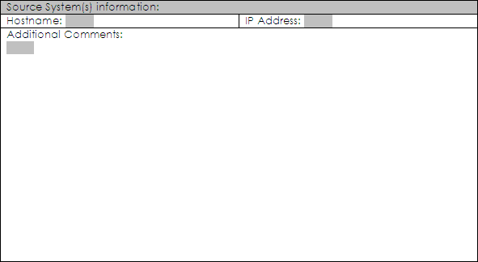

- Hostname: - enter the hostname, preferably the host(s) FQDN.
- IP Address: - enter the presumed IP address or addresses of the suspected source host(s).
- Additional Comments: - any comments the incident handler thinks should be included. These can include country/origin information, and any details on the identification of the suspected source host(s).

Incident Detail – Affected System(s) Information

The incident handler enters all affected systems in this section along with actions performed and impact.

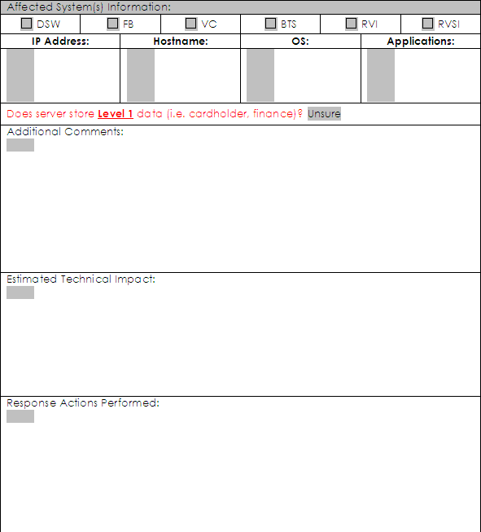

- Select LOB(s) that the affected system(s) belong to.
- Provide IP Address, Hostname, OS, and applications that reside on the affected system(s).
- Determine if the system(s) host Level 1 data, if so; follow the required steps in the “IRP_v02-1” document.
- Additional Comments: - enter any additional comments that warrant being included in regards to the affected system(s) and the investigation. This can include patch levels, VLAN info, firewall rules, etc.
- Estimated Technical Impact: - this does not have be a quantitative risk analysis, but a general statement of what the technical impact of the incident was/is. For example, "Email was down for two hours."
- Response Actions Performed: - enter all actions performed to investigate and resolve the incident including eradication and recovery if necessary.

Incident Detail - Other Organizations, Evidence

During and investigation it may be determined that outside organizations need to be involved. This section is to be used to document who was contacted, why they were contacted and type of organization.

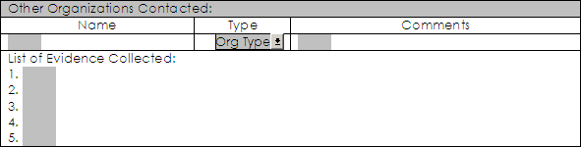

- Name: - enter the name of the outside organization.
- Type: - select type of organization from drop down list.
- Comments: - enter why outside organization was contacted. Also, provide contact information from the organization.
- List of Evidence Collected: - enter a list of all items collected as evidence. This may include items such as, system logs, screen captures of scans, etc.

Incident Detail – Resolution, Sign-off

This is the final section of the “Incident Response Form”, and requires senior management sign-off. The detail should include a clear path to resolution which metrics can be run against.

- Resolution: - provide a detailed resolution to the incident outlining the exact steps taken to resolve incident and close case. This field may be used for future incidents to provide a faster resolution.
- Management Approval: - this section serves as official acceptance by senior management of the case closure and all methods used to do resolve incident and close case.

Note: The Incident Response Form requires business (or IT) Director and IT Security Director sign-off.


Appendix A – Incident Response Flow

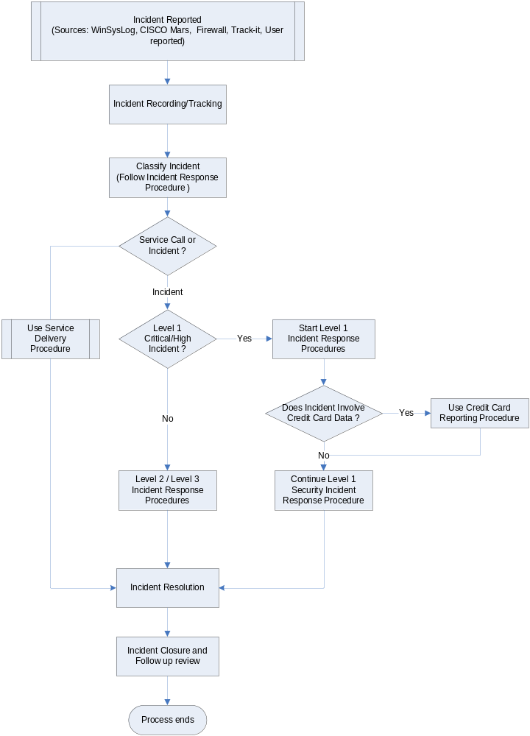

Appendix B – Case Classification, Prioritization, and Notification

Case Classification

TABLE 1 – Incident Severity Levels
Severity Level | Criteria for Assigning Severity Level
Low | Impact is minimal and usually limited to internal application. Examples are harmless e-mail SPAM, isolated virus infections, etc.
Medium | Impact is significant but isolated. Examples are individual store unable to take a payment, or individual store delay in credit card authorizations.
High | Impact is severe or widespread. Examples are a Level 1 data breach, significant disruption to a payment channel, proprietary or confidential information is compromised, a virus or worm is widespread affecting over 20% of employees, or Executive management reported the virus.

Case Prioritization

Incident Level | Initial Response Time | Targeted Resolution Time
Level 1 - Critical | 15 minutes | 1 hour
Level 1 – High | 1 hour | 8 hours
Level 2 | 4 hours | 24 hours
Low | 24 hours | TBD

Incident Escalation

TABLE 2 – Escalation Levels
Escalation Level | Description
0 | Normal operations. IT groups monitoring various sources.
1 | A potential threat has been discovered, determine defensive action. Manager of IT Security determines whether to raise Escalation Level.
2 | A threat has manifested itself and is considered sever enough to warrant escalation by the Manager of IT Security. Determine course of action for containment and eradication.

Incident Notification

Name | Position | Cell phone | Home phone
Jon Ricker | EVP Strategic Business Development, CTO – DSW | 614 476-5709 | 614-855-8023
Doug Probst | EVP Finance, CFO – DSW | 614-738-9352 | 614-855-4784
Bill Jordan | VP, General Counsel - DSW | 614-493-7888 | 614-855-4262
Kevin Lonergan | EVP, COO - DSW | 614-746-6163 | 614-855-8861
Joe DiMariano | VP, Loss Prevention - DSW | 614-872-1600
(TBD) | EVP, CIO
Julie Davis | EVP, General Counsel | 614-565-8581 | 614-784-1689
Brian Cline | VP Operations/Infrastructure | 614-592-7471
Rob Burns | Director , IT Security & Network Services | 614-917-9888
Tim Bullian | Director Internal Audit | 614-306-0970 | 614-759-6563
Jerry Bisaha | Director Customer Systems | 614-478-2324 | 614-895-7114
Anne Marie Meyer | Program Manager – IT Compliance | 614-270-5790 | 614-447-8725

Appendix C - Incident Handler Resources

Tools, Commands, and Web Sites

Host Identification
Windows Command-line Tools
nslookup IP Address
nslookup RemoteName
ping –a IP Address
nbtstat –a RemoteName
nbtstat –A IP Address
Linux Command-line Tools
nmap –sP IP address
Port Information
http://www.iana.org/assignments/port-numbers
http://www.iana.org/numbers.html
Vulnerability Information
http://www.cve.mitre.org
http://www.securityfocus.com/bid

Additional Resources

NIST SP 800-86 – “Guide to Integrating Forensic Techniques into Incident Response”
NIST SP 800-61 – “Computer Security Incident Handling Guide”

